Project title: Online Blood Bank Web System

Development Platform: Laravel, Sql

You have to do “Not done” features. Means complete everything.

Please download all the files, so actually your work will be to check requirement first which id Doc, I listed whatever I have done and whatever haven't done yet which you need to complete based on the requirement and following the flow chart which is pdf file. Finally, you need to extract the zip file and run the coding Whatever I have done till now.

<https://drive.google.com/drive/folders/1FLMkD8puwqYnzwT-QQOktELrNJddZLlp>

I need to develop an online blood donation (centralised) system for this project. It looks like this https://www.eraktkosh.in/BLDAHIMS/bloodbank/transactions/bbpublicindex.html as reference but my objective is just Penang government hospital and private hospital and blood bank only (Note: Penang is a state in Malaysia).

Project Objectives

Requirements

1. First help me to solve the multi-auth middleware for hospitals and admin.

1. I need help on the foreign key which add in migration and inner join the appointment table with userID to display the user information.

1. Create an appointment form in view/auth/appointment, and you can go to the hospital list page, there is a button for make appointment for donor to click on it then bring them to appointment interface. Donors cannot make appointment immediately must make the appointment 2 days before and show the rules to them that what must need to be pay attention before going to donate blood.

1. My idea on appointment table for database:

- appoitnmentId

- inner-join userID, name, bloodType, ic, phoneNo

- appointmentDate

- appointmentTime

- appointment status ->default(0) //set as pending //pending is 0, success is 1 and fail is 2

- userID

1. Create view appointment status front-end and back-end

1. Create event page in donors’ side which allow them to register also (the event listed in donor side is hospital which registered in the system adding the event at hospital side)

1. Admin forgot-password there have a bug which cannot reset password but user and hospital is working well.

1. In donor side (My Profile) how to display the stateName instead of display stateID. Help to display unhash password then add-on is it donor wants to change new password.

1. For Hospital and Admin side I haven’t develop yet so just refer to the use case diagram but must have dashboard for both with the second objectives.

Done with function (fyp-laravelBreeze.rar)

1. Guest view home page
2. Guest view about us page
3. Guest view contact us page
4. Donor Registration
5. Donor Login
6. Donor forget and reset password
7. Donor home page
8. Donor view and search hospital page
9. Donor about us page
10. Donor contact us page
11. Hospital Registration
12. Hospital Login
13. Hospital forget and reset password
14. Admin Registration
15. Admin Login

Not Done

1. Donor event page and function
2. Donor make appointment page and function
3. Donor view appointment page and function
4. Donor dashboard
5. Donor (My Profile) need check
6. Hospital dashboard
7. Hospital search donor page and function
8. Hospital view and update blood bank inventory page and function
9. Hospital request blood, request emergency blood and view blood request page and function
10. Hospital add event which held by their hospital page and function
11. Hospital update profile page and function
12. Hospital record status for donor is done for blood donation or not
13. Admin dashboard
14. Admin view, add and search all donor page and function, extends view all donor appointment and approve or reject the donor appointment page and function
15. Admin view, add and search all hospital page and function
16. Admin view all hospital blood bank inventory and alert if inventory of certain blood type is low page and function
17. Admin need send blood to the hospital if the hospital blood bank inventory is low page and function
18. Admin need take alert on emergency request by hospital and send the certain blood type to the hospital which facing emergency situation by exchange with others blood type with other hospital page and function
19. Admin need approve the event add by hospital page and function
20. Admin update profile page and function
21. Admin record and update for blood request/ emergency blood request

FAQ:

Question 1:

First help us to solve the multi-auth middleware for hospitals and admin.

This is first requirement. so here. we are not sure what we should do here.. Seems it's already implemented in your current script.

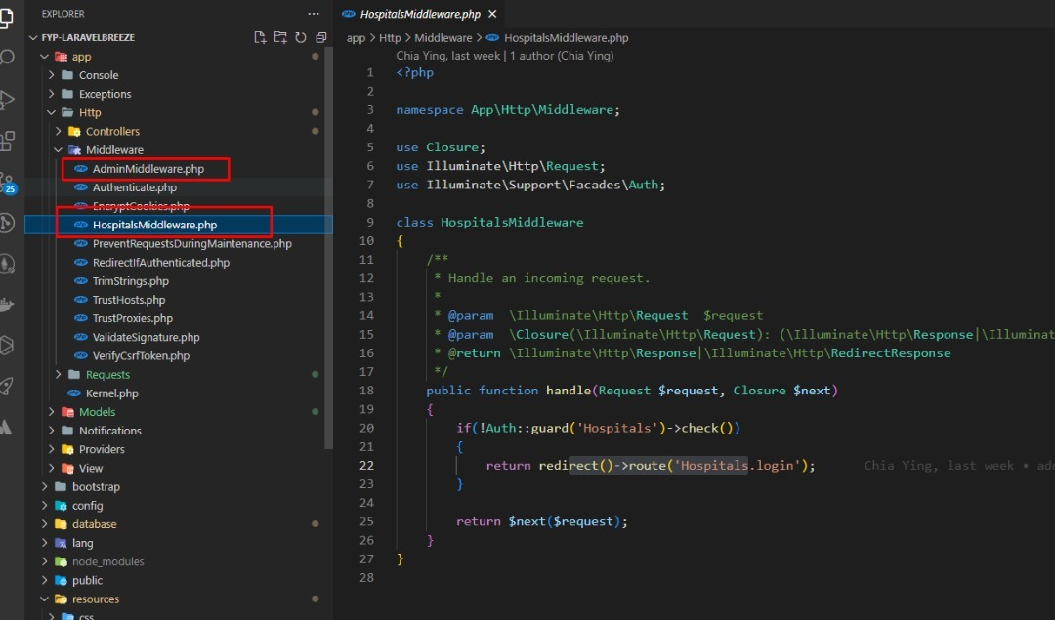

Answer: Ok now the problem is when you start the system then hospital want to login it will direct bring the user to donor login first then logout only can let hospital and admin to login

Can we do like this which means is the login status is not on the each role of the user can go their login page to login

But if there is any login status on in donor, hospital or admin will need to logout then only can login

It not works because I think the code is still haven’t completed or I had miss some part of code is it?

Question 2: So do you want to login multi role on just one browser?

Answer: Multi role, I follow from YouTube is call muliAuth function, <https://youtu.be/T9q1uT2BEZI>

Question 3:

Point No 1 (From not done) Donor event page and function What is donor event?

Answer: Donor can search event will held by the hospitals. I think need to do the hospitals add event first only donor can search and view the event

Question 4: So what is the difference between event and appointment? I mean why do we need 'event'?

Answer: The event is like about blood campaign, or can let the sponsor collaborate with hospitals to held an event like charity run to promote about the importance of blood donation. So that if donors is interested they can register themselves in the system

Question 5: Point No 5 (From not done) Donor (My Profile) need check. what this part does.

Answer: It's user profile, User can only update their contact number, address and password. Others information like name, ic, gender, blood type cannot be edited

Quesiton 6: Point No 11 (From not done) Hospital update profile page and function

Every hospital need its profile page?

Answer: Yes